# Change time



10:00 am to 7:30pm

Sun- 10:00am to 2:00pm

# Change pic

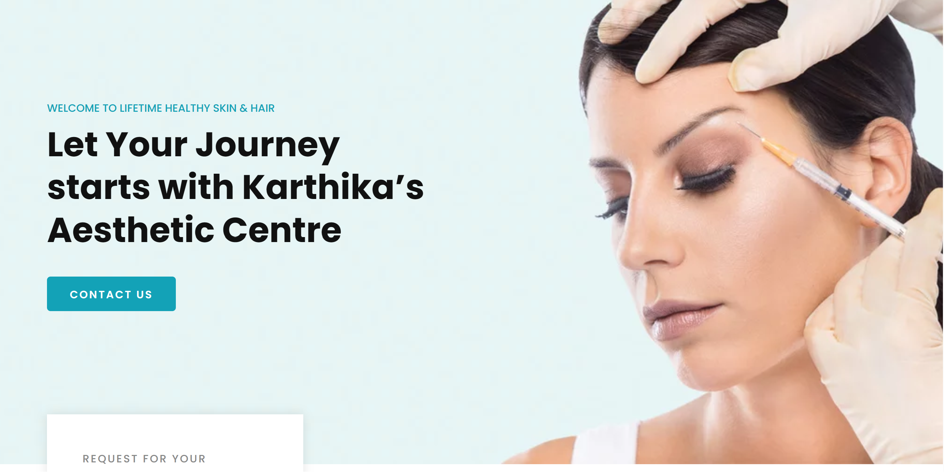

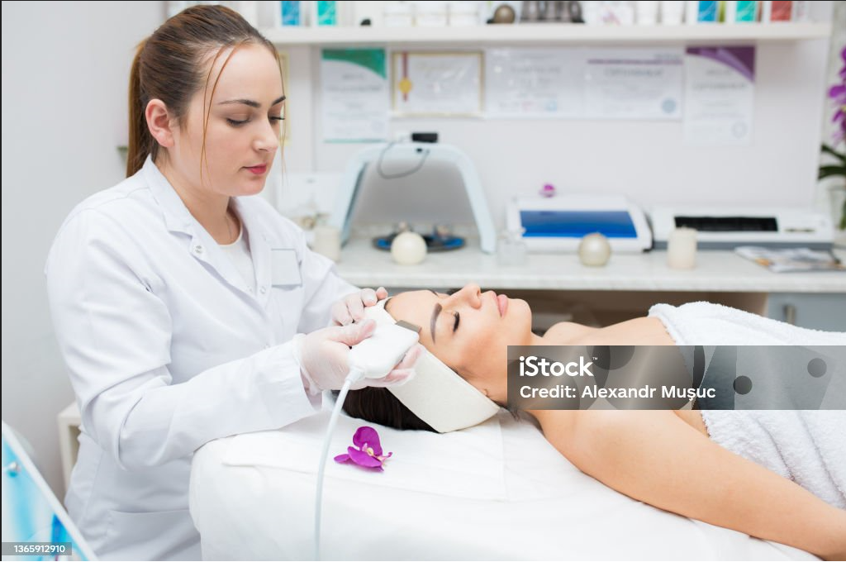

# short content

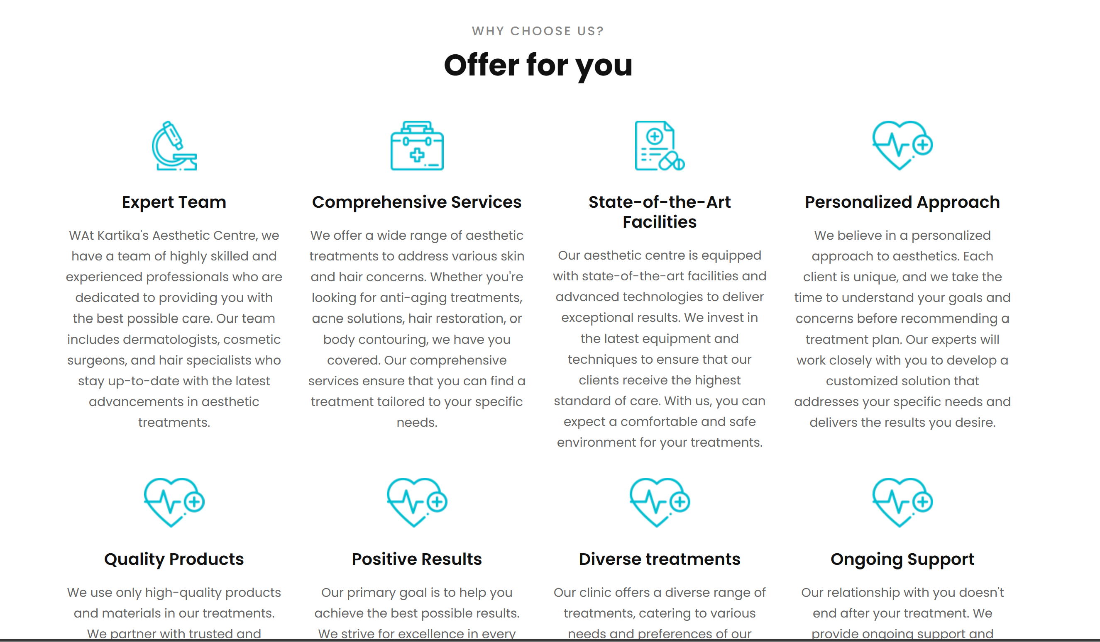

Expert Team:

Our clinic is home to a carefully assembled team of experienced and skilled professionals dedicated to providing you with the highest standard of care and expertise.

Comprehensive Services:

We offer a wide range of comprehensive services designed to address all your aesthetic concerns under one roof, ensuring a holistic approach to your well-being.

State-of-the-Art Facilities:

Enjoy the comfort and confidence of our state-of-the-art facilities, equipped with the latest technology and designed to provide you with a safe, relaxing environment.

Personalized Approach:

We understand that every individual is unique, which is why we tailor our treatments to your specific needs, ensuring a personalized approach for the best possible results.

Quality Products:

We only use the highest quality products and materials in all our treatments, ensuring your safety and satisfaction at every step of your journey with us.

Positive Results:

Experience the transformative power of our treatments, which are designed to deliver consistently positive results, enhancing your natural beauty and confidence.

Diverse Treatments:

From rejuvenating facials to advanced body contouring, our clinic offers a diverse range of treatments to cater to all your aesthetic desires and requirements.

Ongoing Support:

At Karthika’s Aest Centre, our commitment to your well-being doesn't end with your treatment. We provide ongoing support and guidance to help you maintain your results and achieve lasting satisfaction.

# Short content

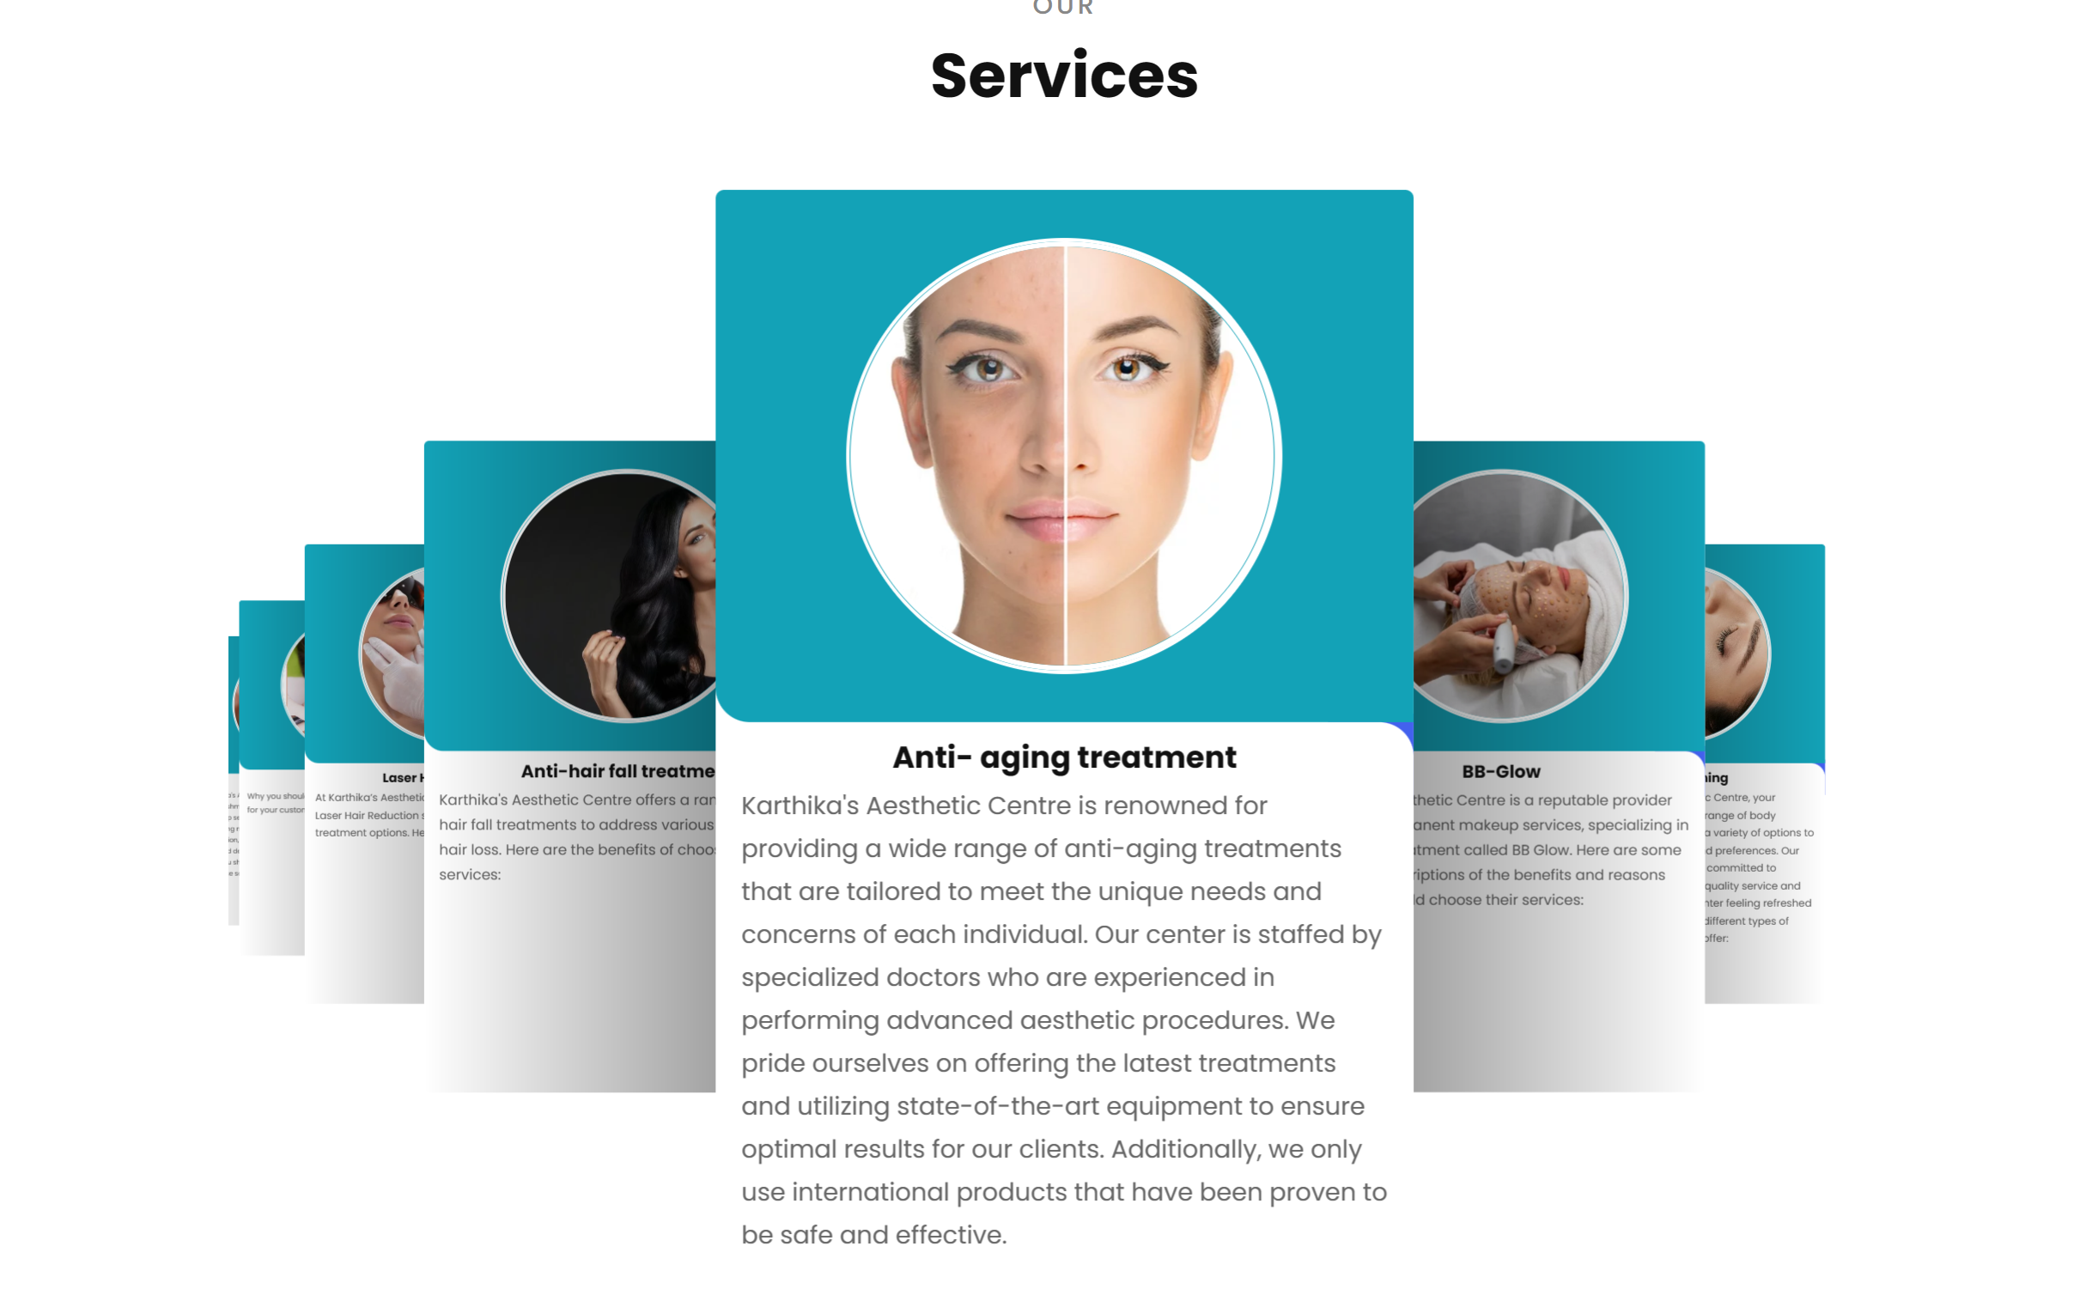

hydra facial

HydraFacial is a non-invasive, customizable facial treatment that combines cleansing, exfoliation, extraction, hydration, and antioxidant protection. Suitable for all skin types, this quick and versatile procedure delivers immediate results, addressing various skin concerns such as fine lines, wrinkles, hyperpigmentation, and acne. With no downtime and a reputation for providing a healthy glow, HydraFacial has become a popular choice for individuals seeking a refreshing and effective skincare solution.

hair laser reduction

Laser hair reduction is a popular and minimally invasive cosmetic procedure that uses concentrated light to target and destroy hair follicles, inhibiting hair growth. This efficient and long-lasting solution is sought after for its precision, speed, and ability to target multiple hair follicles simultaneously. With minimal discomfort and a high success rate, laser hair reduction has become a widely favored option for those seeking a more permanent alternative to traditional hair removal methods.

anti hairfall treatment

Anti-hairfall treatment is a targeted approach to address hair loss and promote hair regrowth. Utilizing various techniques, these treatments aim to strengthen hair follicles, reduce shedding, and enhance overall hair health. From topical solutions to laser therapies, anti-hairfall treatments offer effective strategies for combating hair loss and fostering thicker, healthier hair.

anti aeging treatments

Anti-aging treatments encompass a range of interventions designed to minimize the effects of aging on the skin. From topical creams to advanced procedures like Botox and dermal fillers, these treatments aim to reduce wrinkles, fine lines, and age-related skin changes. By promoting collagen production and restoring skin elasticity, anti-aging treatments contribute to a more youthful and revitalized appearance.

bb glow

BB Glow is a cosmetic procedure that involves microneedling a tinted serum into the skin for a semi-permanent foundation effect. This treatment aims to even out skin tone, reduce imperfections, and provide a radiant, dewy complexion. Often sought after for its natural-looking results, BB Glow is a quick and non-invasive solution for those desiring a subtle and long-lasting enhancement to their skin's appearance.

body polishing

Body polishing is a spa or skincare treatment focused on exfoliating and rejuvenating the skin's surface. Using a combination of scrubs, oils, and massage techniques, this procedure helps remove dead skin cells, improve skin texture, and promote a smooth, polished finish. Body polishing is valued for its ability to leave the skin refreshed, glowing, and revitalized.

lip contouring

Lip contouring is a cosmetic technique that enhances the appearance of the lips. This involves using makeup or dermal fillers to define the lip borders, add volume, and create a more aesthetically pleasing contour. Lip contouring aims to achieve fuller, well-defined lips for a balanced and enhanced facial appearance.

# Our other services

# Offer for you

# Karthika’s institute of cosmetology studies

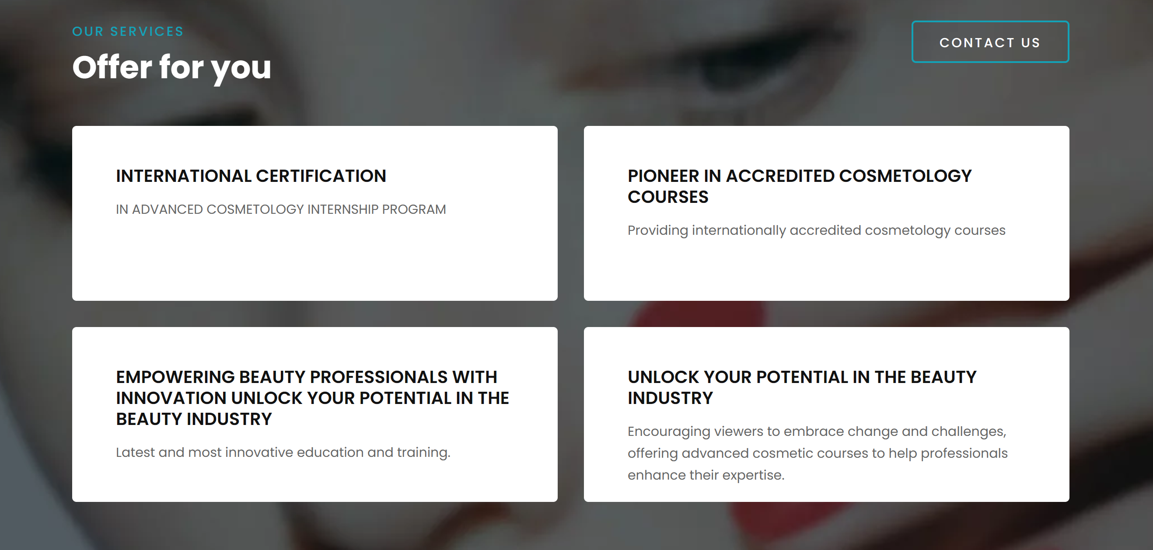

# Team karthika’s

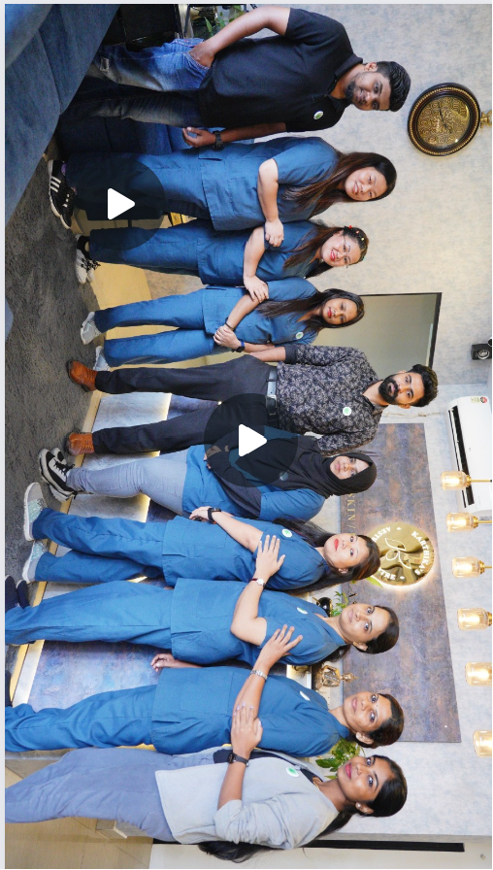

# Change pics

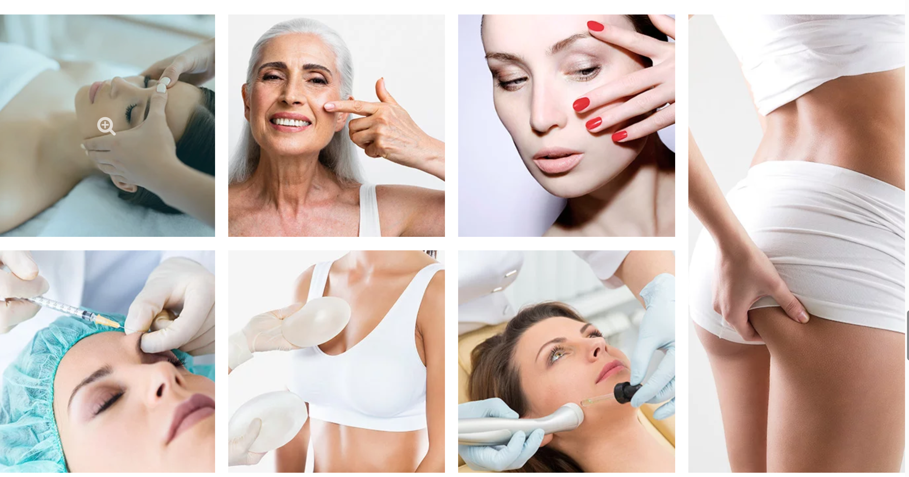

Services pic

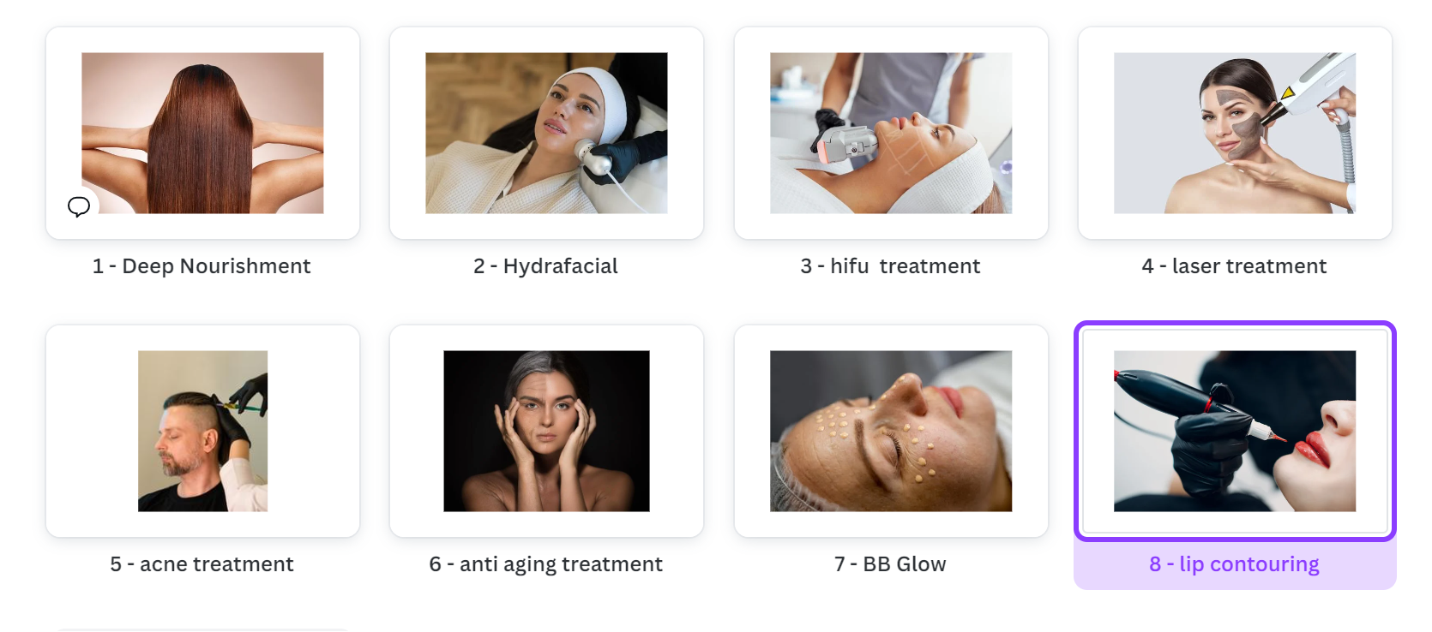

# Change as google reviews

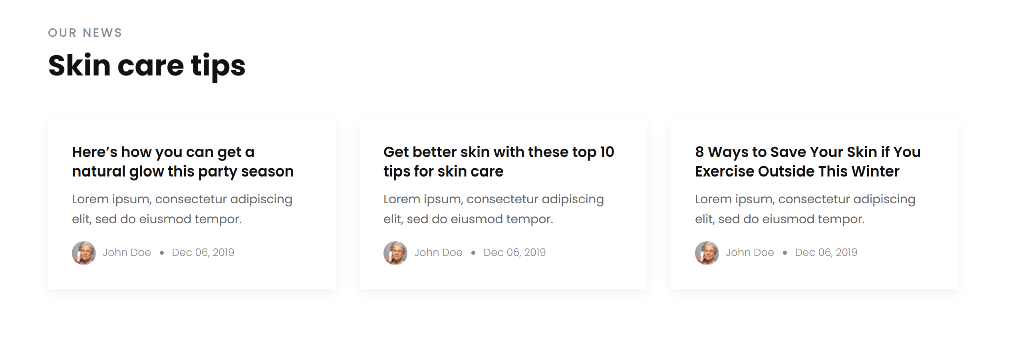

# Google Reviews

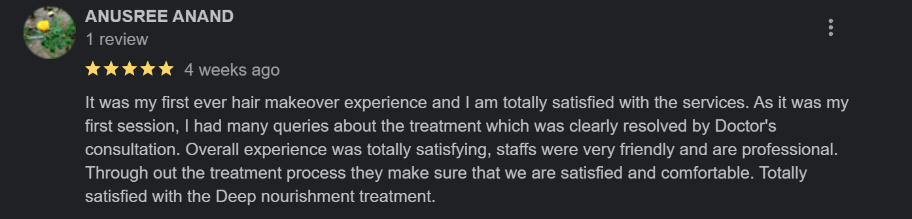

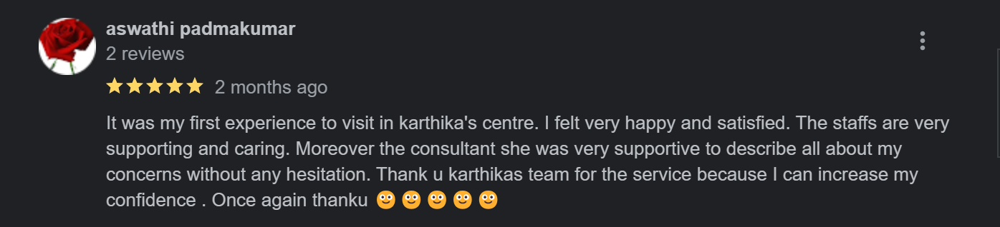

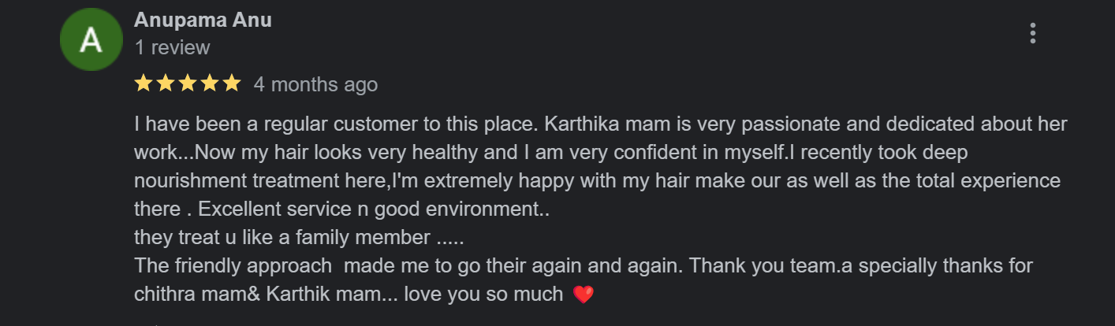

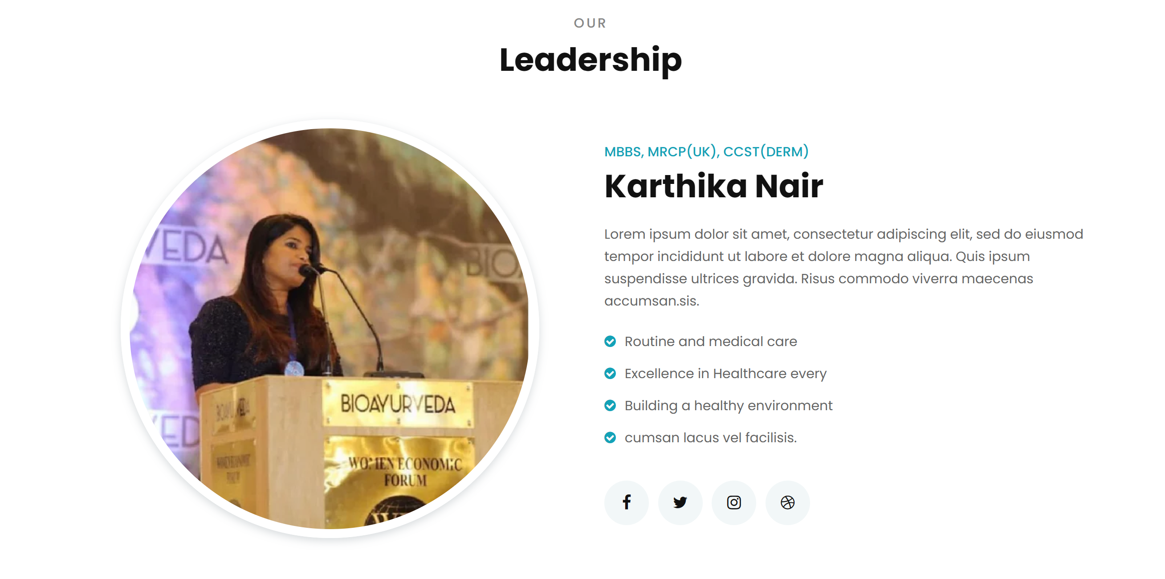

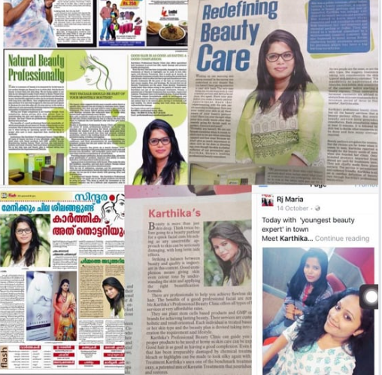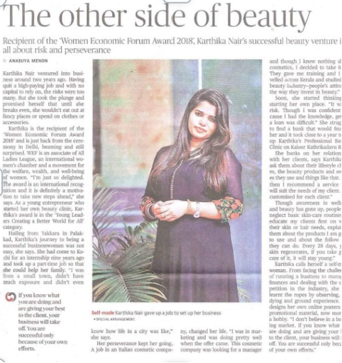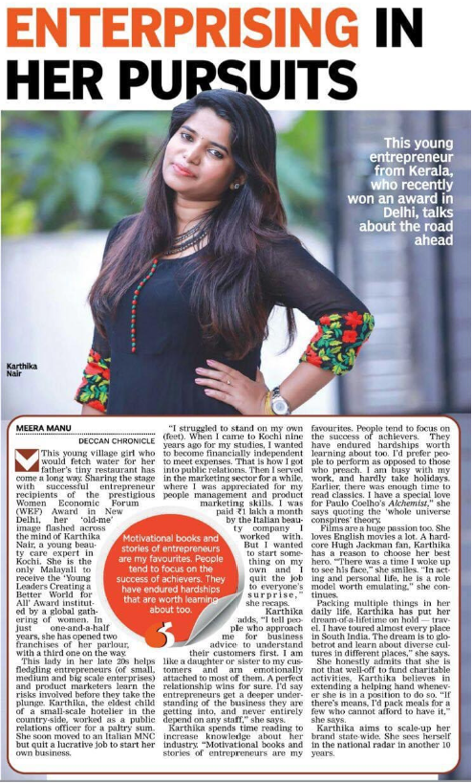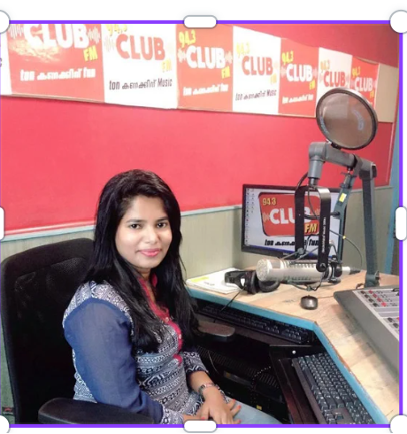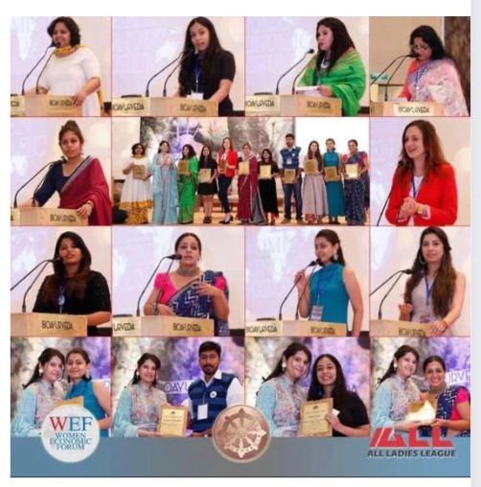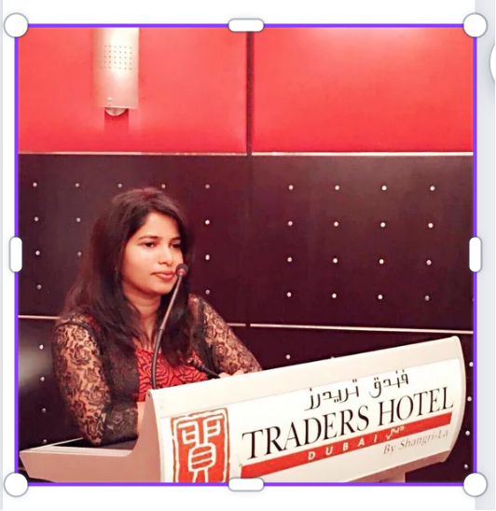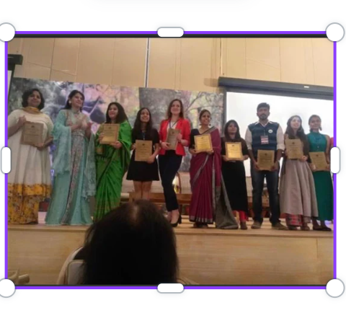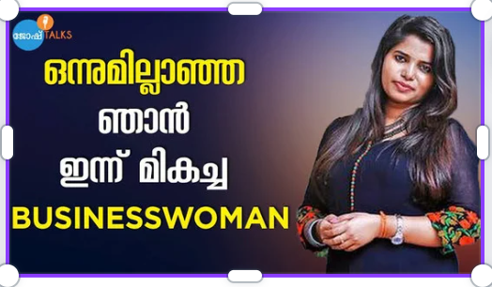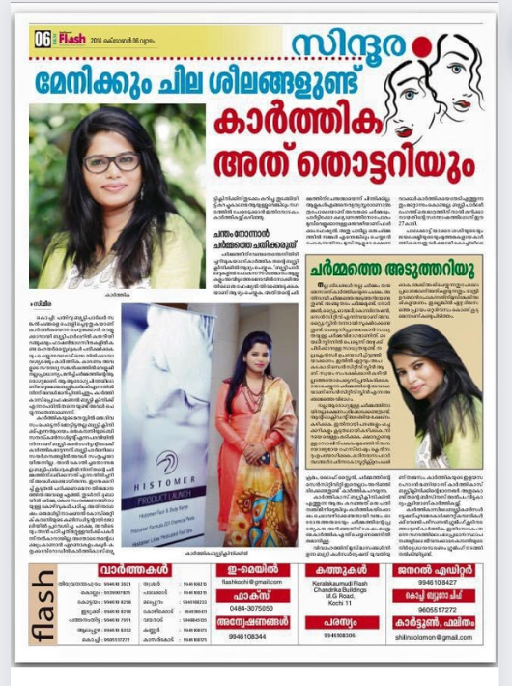

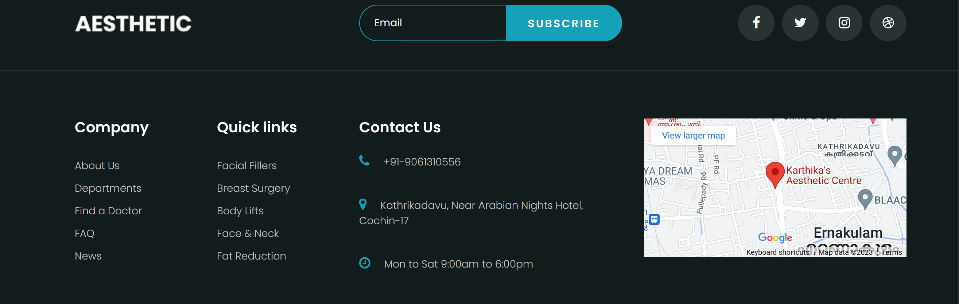

# Add Treatments List